**The Room 2.0**

You are a student and you do not have enough space in your room? You will be pleased to know that I participated a meeting held at the university in order to improve student’s life conditions. This will happen soon!

Several company make up of trios (an architect, a project designer and a student) were present to show the room of the future. I will present the project that have attracted my attention. They must bring a green feature and a building automation in a room. Each one has approached the subject differently. Some decided to highlight the mobility of their room and other decided to highlight the environmentally friendly and practicality of their furniture. Furthermore, you can find in this apartment all you need: a kitchen, a shower, a bed, a balcony…

In terms of mobility, it is Habib that he attracted my attention with removable bed. He can be put in movement in order to leave space for a desk to work for example. This invention allows to win a lot a of space in the room, which is the real problem in a student room. In regards of green feature, he decided to add solar windows allowing to do saving in electricity.

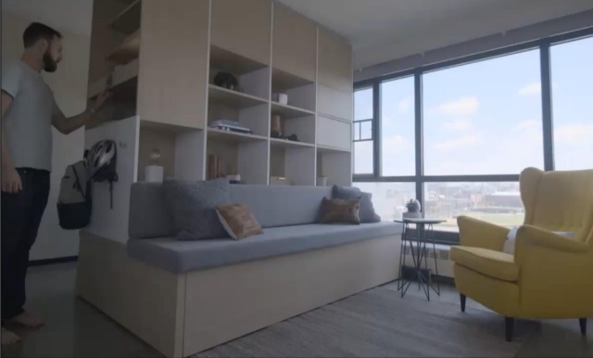

Then in terms of ecological and practical furniture, it is Vincent who has showed is project. All his furniture was adapted at the room with good size and with storage. But the real revolution concerns the management of the temperature. Thanks to a tablet computer, you can regulate your temperature and thus, you will can do saving in your economy.

The selected project is not yet known but know that it does not matter who is selected, you will be love your new life in these room of the future.

Guilpain Léo